**AI LAB ASSIGNMENT 9.3:**

Name:V.Nithya

Hall ticket no:2403A52346

**Task 1:Write a python program to return sum of even and odd numbers in the given list.**

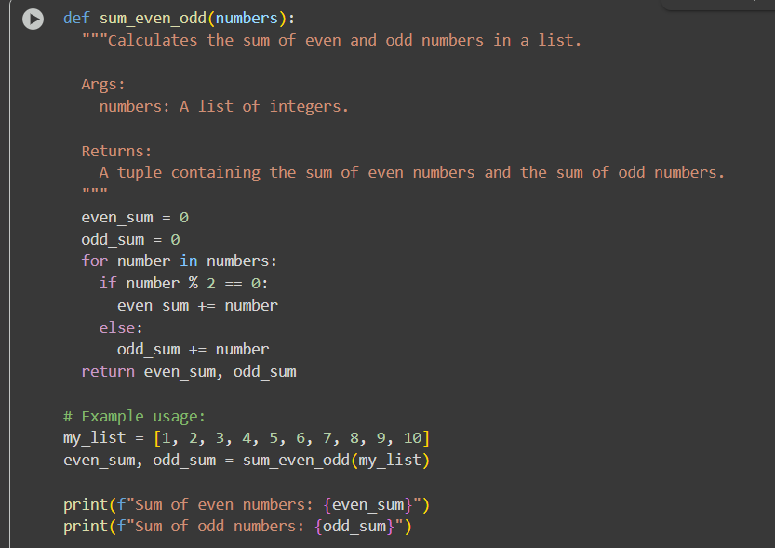

**Output:**

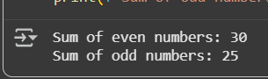

**Explanation:**

**Task 2:Write python program for sru_student class with attributes like name, roll no., hostel_status and fee_update method and display_details method.Write comments manually for each line/code block add inline comments explaining each line.**

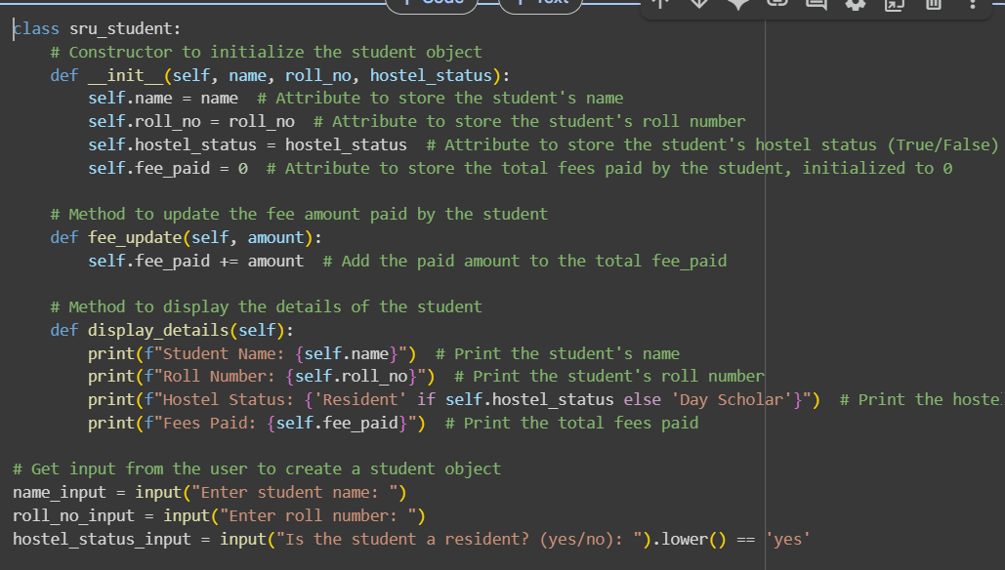

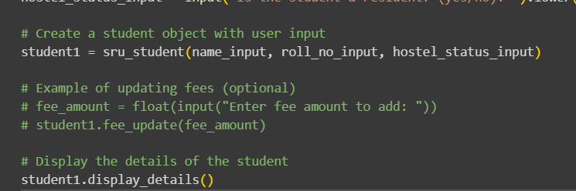

**Output:**

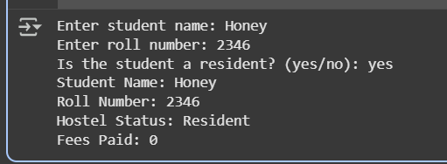

**Explanation:**

**Task 3:** **Write a Python script with 3–4 functions (e.g., calculator: add, subtract, multiply, divide).Incorporate docstrings.**

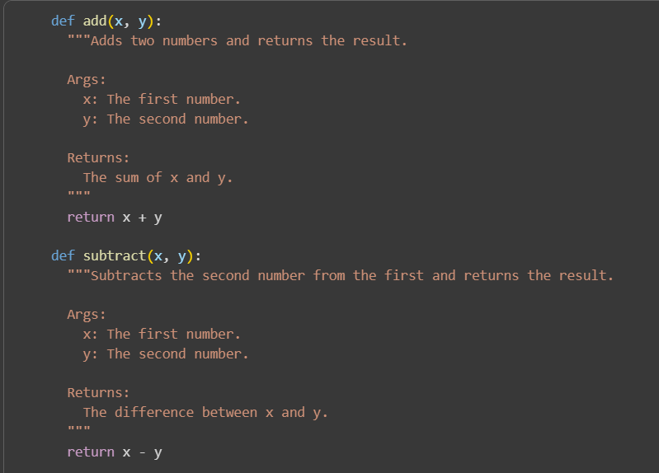

**Output:**

**Explanation:**

